A PROJECT REPORT
On
IPO PREDICTION
For
DSE2220-Machine Learning
By
Pratyush Rawat
Dudhat Ayush
Section - C
23FE10CDS00288
23FE10CDS00293



School of Computer Science and Engineering-2
Department of Data Science and Engineering

MANIPAL UNIVERSITY JAIPUR
RAJASTHAN, INDIA
April 2025
CONTENTS
 |  |  |  | Page No
Chapter 1 |  |  | INTRODUCTION
 | 1.1 | Introduction |  | 3
 | 1.2 | Problem Statement |  | 3
Chapter 2 DATASET Description and Preprocessing
 | 2.1 | Dataset Description |  | 5
 | 2.2 | Data Pre-processing |  | 6
Chapter 3 |  |  | MACHINE LEARNING TECHNIQUES
 | 3.1 | Brief Description of ML Techniques used |  | 8
Chapter 4 |  |  | RESULTS
4.1 |  |  | Results | 14

Chapter 1 - INTRODUCTION

1.1 Introduction

An important milestone for businesses entering public markets is an initial public offering (IPO), which gives investors access to potentially high-return investments and provides a means of raising funds. However, IPOs are a difficult area for investors due to their unpredictability, which is characterized by a lack of historical data, speculative sentiment, and market volatility. IPOs, in contrast to established equities, are impacted by special elements that are frequently disregarded in conventional stock prediction models, such as pre-launch marketing, investor sentiment, and macroeconomic conditions.

Financial forecasting has been transformed by machine learning and big data, but there is a lack of prediction tools tailored for initial public offerings (IPOs) because current models mostly concentrate on well-known stocks and market indices. By creating a machine learning-based program specifically designed for IPO profitability predictions, our study seeks to close this gap.

To give investors precise and useful insights, the model combines financial measures, real-time sentiment research, and previous IPO data. The initiative aims to enable investors to manage the intricacies of initial public offerings (IPOs) by utilising sophisticated algorithms and data analytics. This will lower risks and enhance decision-making in this crucial area of finance.

1.2 Problem Statement
Despite the growing popularity of IPO investments, predicting IPO profitability remains a challenging task due to the lack of historical trading data, market volatility, and multiple influencing factors such as investor sentiment, subscription rates, and macroeconomic trends. Traditional financial models are inadequate for IPO scenarios as they often rely solely on static company fundamentals and do not account for dynamic and qualitative data.
There is a critical need for a robust, data-driven solution that can accurately assess IPO profitability before market listing by integrating diverse data sources and leveraging machine learning techniques.
This project addresses the problem by developing a predictive system that combines financial metrics, historical IPO data, engineered features, and sentiment analysis to forecast IPO outcomes and guide investors with actionable insights.
The core problem this project addresses is:
Can machine learning models be used to accurately and efficiently predict the opening price and expected listing gain of the IPO?
Given a dataset containing historical Indian IPO market data with subscription metrics and listing outcomes, the task is to build and evaluate machine learning models that can:
- Analyze patterns from IPO features such as issue size, price, and subscription ratios
- Accurately predict whether an IPO will list with positive gains on opening day
- Provide estimates of expected listing price and percentage gain/loss
- Identify the most influential factors affecting IPO performance
- Enhance prediction reliability through advanced ensemble methods
By leveraging machine learning techniques including neural networks, random forests, and gradient boosting, this system aims to support investors with data-driven insights for making informed IPO investment decisions. The model integrates comprehensive feature engineering, handles class imbalance, and implements hyperparameter tuning to maximize predictive accuracy.

Chapter 2 - DATASET DESCRIPTION AND PREPROCESSING

2.1 Dataset Description

The dataset used in this project is sourced from a CSV file and contains detailed information about Initial Public Offerings (IPOs) in the Indian stock market. It compiles data on various IPOs launched across different years, capturing essential financial metrics and stock performance indicators. This dataset can be used to explore trends, analyze IPO success factors, and build predictive models for IPO price movement.

The primary objective of this dataset is to assist in understanding the relationship between different financial attributes (like issue price, listing price, subscription details, etc.) and the performance of IPOs on their listing day or over time.

Format & Structure

Format: CSV (Comma-Separated Values)

Rows: 326 (Each row represents a unique IPO)

Columns: 13 (Attributes related to each IPO)

Target Variable (for prediction-based use cases)

Listing Gain (%): This can be used as the target for regression (predicting the gain/loss on the day of listing).

Alternatively, a binary classification can be built based on whether the listing gain is positive or not.

Features Overview The dataset includes the following key features:

Company Name: Name of the company launching the IPO.

IPO Date: Date when the IPO opened for subscription.

Issue Price (Rs): The price at which shares were offered to investors.

Listing Price (Rs): The price at which the shares were listed on the stock exchange.

Close Price (Rs): The price at the end of the listing day.

Listing Gain (%): Percentage gain/loss from issue price to listing price.

Current Price (Rs): Current market price of the stock (may be NaN for recent IPOs).

Returns (%): Returns compared to the issue price.

Subscription (x): Overall subscription figure (times oversubscribed).

QIB, NII, Retail: Subscription by Qualified Institutional Buyers, Non-Institutional Investors, and Retail Investors.

This dataset provides a comprehensive view of IPO trends and is suitable for use in financial analytics, investment prediction models, and market research.

2.2 Data Pre-processing
Before training machine learning models, the dataset underwent several pre-processing steps to ensure the quality, consistency, and suitability of the data for IPO prediction tasks. Proper data preparation is essential for building reliable models that can accurately predict listing day performance.
1. Loading and Initial Cleaning
- The Indian IPO Market Data was loaded from CSV format
- Date and IPO Name columns were separated from the training features
- The original Listing Gains Percentage was preserved for analysis and transformed into a binary target variable (profitable vs. non-profitable)
2. Feature Engineering
- Interaction Features: Created multiplicative interactions between subscription categories (QIB_RII_Interaction, HNI_RII_Interaction, etc.)
- Ratio Features: Generated meaningful ratios like Size_Price_Ratio and QIB_to_RII_Ratio to capture relationships between variables
- Logarithmic Transformations: Applied log transformations to highly skewed features (Issue_Size, Subscription metrics)
- Polynomial Features: Created squared terms for key variables to capture non-linear relationships
- Statistical Features: Calculated mean, standard deviation, and range of subscription metrics
3. Outlier Handling
- Implemented multiple outlier handling strategies (IQR method, percentile-based clipping, z-score)
4. Feature Selection
- Statistical Tests (ANOVA): Selected features with strong statistical relationships to the target
- Mutual Information: Identified features with high information gain
- Recursive Feature Elimination: Used a Random Forest-based approach to select the most predictive features
- Combined results from multiple selection methods to create a robust feature set
5. Train-Test Split
- Split data into training and testing sets using stratified sampling to maintain class distribution
- Used a fixed random seed (random_state=42) for reproducibility
6. Feature Scaling
- Applied PowerTransformer (Yeo-Johnson method) to handle skewed distributions and normalize features
- Stored the scaler for consistent transformation of new prediction data

7. Class Imbalance Handling
- Applied SMOTETomek, which combines oversampling and undersampling techniques
- Created a balanced training dataset to prevent models from being biased toward the majority class
This comprehensive preprocessing pipeline ensured that the IPO data was optimally prepared for the modeling phase, addressing common challenges like skewed distributions, outliers, and feature selection.

Chapter 3 - MACHINE LEARNING TECHNIQUES

3.1 Brief Description of ML Techniques used
To effectively classify whether a person has Parkinson’s Disease based on their vocal features, this project employed three popular supervised machine learning algorithms, each with its own approach to learning patterns in the data:

1. Logistic Regression
To establish a reliable baseline, we used Logistic Regression. Despite being a linear model, it gave us a strong benchmark for performance. Surprisingly, it achieved the highest AUC score (0.7025) in our evaluations, showing its effectiveness in separating profitable and unprofitable IPOs.
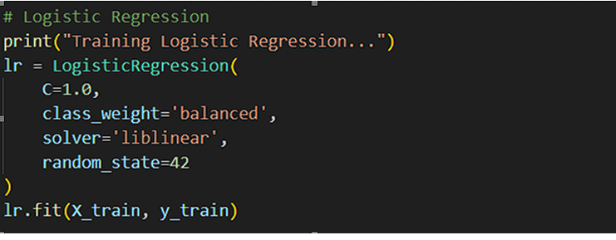
2. Random Forest
We used Random Forest for its ability to handle non-linear relationships and its robustness against overfitting. As an ensemble of decision trees, it provided high accuracy and interpretability by evaluating feature importance. It performed consistently well across various experiments.
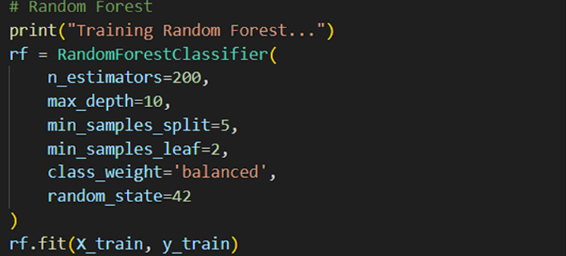3. Gradient Boosting
We included Gradient Boosting to capture incremental learning patterns. This technique builds models sequentially, with each new model correcting errors from the previous one. Although more sensitive to overfitting, it helped us improve performance on smaller nuances in the data.

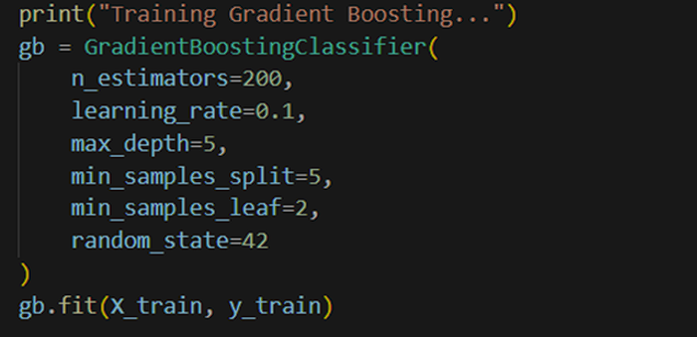

4. Support Vector Machine (SVM)

We used SVM for its strength in modeling complex boundaries between classes. By using kernel functions, we were able to capture non-linear relationships. Though slower to train, it gave decent performance and contributed useful diversity to our ensemble.

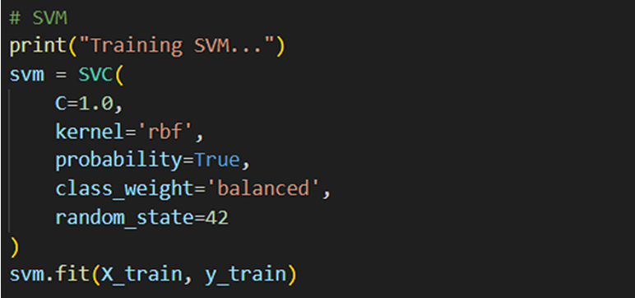

5. Voting Ensemble

We combined multiple models using a Voting Classifier to take advantage of the strengths of each. By aggregating predictions, the ensemble provided better generalization than individual models and smoothed out inconsistencies.

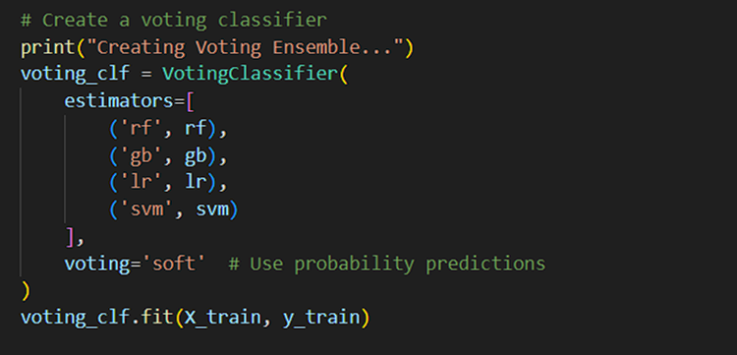

6. Neural Network

To capture deeper, more abstract relationships in the data, we built a Neural Network using TensorFlow/Keras. The model had:
- Two hidden layers with 384 and 128 units,
- ReLU activation,
- Dropout (0.4, 0.3),
- L2 regularization,
- And class weights for imbalance handling.

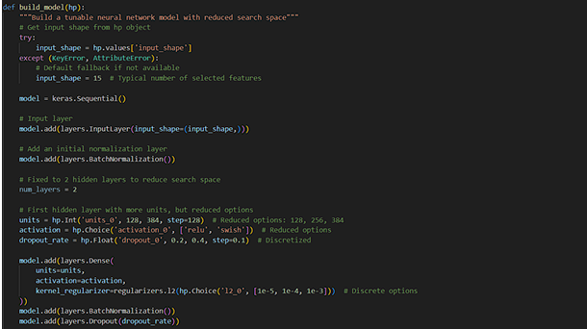

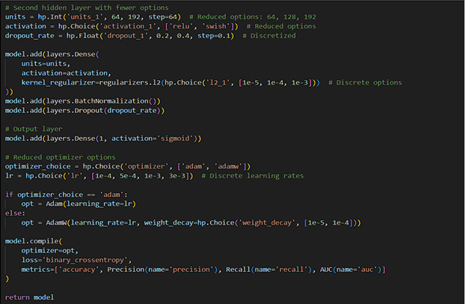

7. Bayesian Optimization

To fine-tune our Neural Network, we used Bayesian Optimization for hyperparameter tuning. Over 200 trials, we searched for the optimal architecture and training configuration. We used callbacks like EarlyStopping and LearningRateScheduler to speed up training and avoid overfitting.

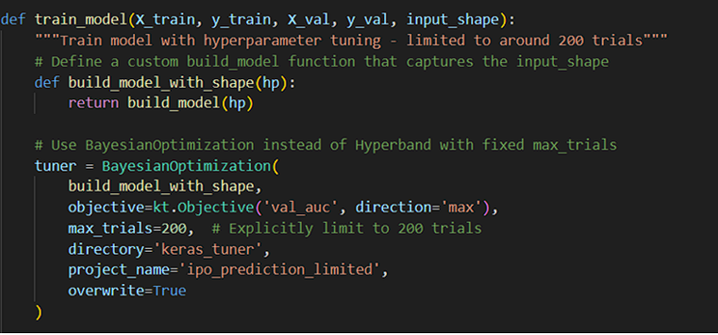

8. Hyperparameter Tuning

To improve our model’s performance and generalizability, we implemented hyperparameter tuning using Bayesian Optimization. This approach helped us efficiently explore the parameter space without exhaustive search. We conducted 200 trials to identify the optimal configuration for our neural network, focusing on key parameters such as:
- Number of units in each hidden layer
- Dropout rates
- L2 regularization strength
- Learning rate
- Optimizer settings

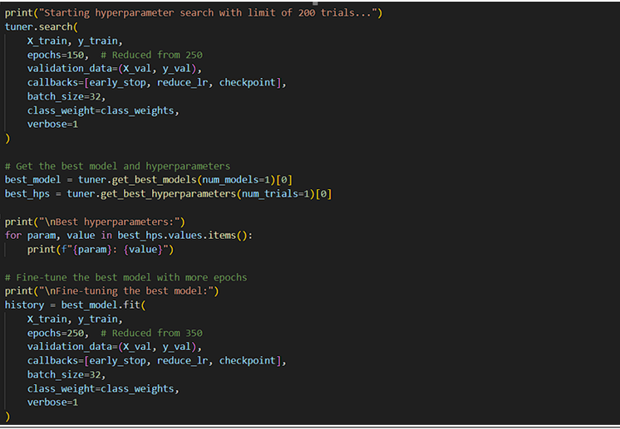

This code performs hyperparameter tuning (200 trials) for a neural network, using reduced epochs (150 vs. 250) for efficiency. It employs callbacks (early stopping, learning rate reduction, checkpointing) and class weights to handle imbalance. After selecting the best model, it fine-tunes with 250 epochs. The process balances thorough optimization with computational constraints.

Chapter 4 - RESULTS

4.1 Results
After training and evaluating multiple machine learning models, we obtained insightful results that validated our approach. Among all models tested, Logistic Regression performed the best in terms of AUC (0.7025), followed by Random Forest (AUC 0.6837). Other models like SVM, Gradient Boosting, and the Voting Classifier also showed competitive performance.
Our Neural Network model achieved a training accuracy of 85%, but the validation accuracy plateaued around 74%, indicating some overfitting. Despite that, it maintained a strong AUC (~0.9), showing it could distinguish between classes effectively.
We further evaluated the models using confusion matrices, classification reports, and ROC curves. The optimal threshold was identified around 0.5, where both precision and recall were balanced.
In our prototype test, the system predicted the IPO of MRF to be profitable with a listing gain of 31.24%, a predicted opening price of ₹59.06, and a 72% confidence from the ensemble model. Based on these insights, the system gave a Moderate BUY recommendation.
ROC CURVE—
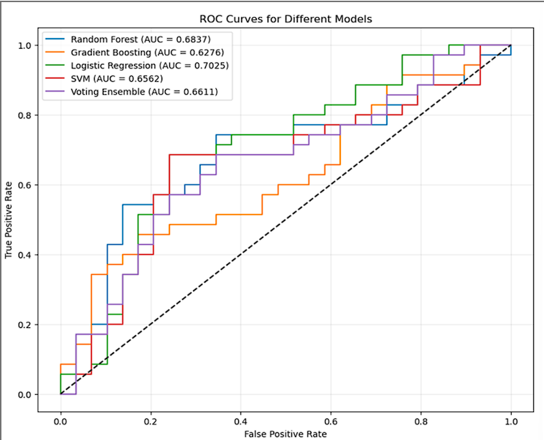
This ROC (Receiver Operating Characteristic) curve compares the performance of five classification models: Random Forest, Gradient Boosting, Logistic Regression, SVM, and a Voting Ensemble. The ROC curve plots the True Positive Rate (TPR) against the False Positive Rate (FPR) at various threshold levels. A model with a curve closer to the top-left corner performs better, as it achieves higher TPR while maintaining low FPR.
The AUC (Area Under Curve) values indicate overall model performance:
- Logistic Regression performs the best with an AUC of 0.7025.
- Random Forest follows with an AUC of 0.6837.
- Other models—SVM (0.6562), Voting Ensemble (0.6611), and Gradient Boosting (0.6276)—show slightly lower performance.
The dashed diagonal line represents random guessing (AUC = 0.5). All models outperform this baseline, but Logistic Regression clearly leads in distinguishing between positive and negative IPO outcomes, making it the most effective model in this comparison.

Confusion Matrix—
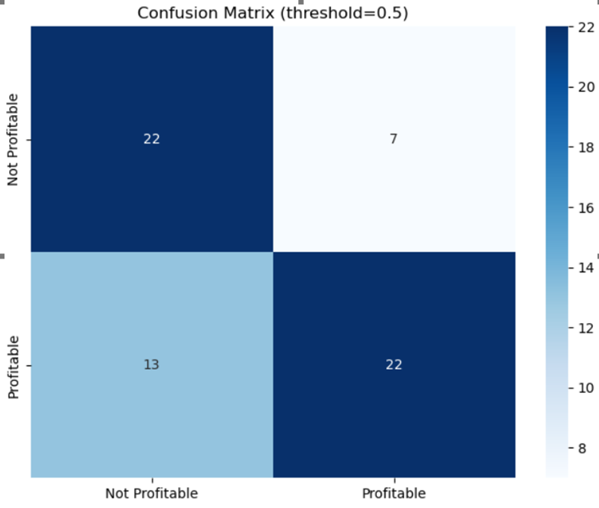

The confusion matrix shows 22 correct predictions each for both profitable and not profitable cases. There are 7 false positives and 13 false negatives. The model performs reasonably but struggles more with identifying profitable instances, as indicated by the higher number of false negatives compared to false positives.

Metrics vs Threshold graph—
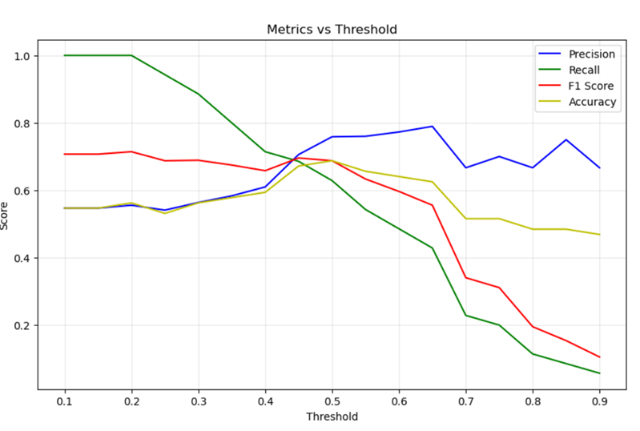
The graph shows how model metrics vary with threshold. As the threshold increases, precision rises while recall drops sharply. F1-score and accuracy peak around 0.5, indicating it as the optimal threshold. Beyond this, recall deteriorates rapidly, reducing overall model performance despite increased precision.

Classification report-
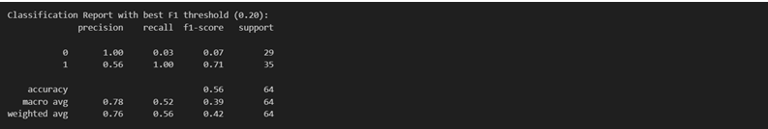
This classification report shows model performance with a threshold of 0.20 for class prediction. Class 1 (positive) has high recall (1.00) but moderate precision (0.56), resulting in an F1-score of 0.71. Class 0 (negative) has perfect precision (1.00) but very low recall (0.03). The overall accuracy is 56%, indicating the model favors detecting class 1 at the cost of class 0.

Output--
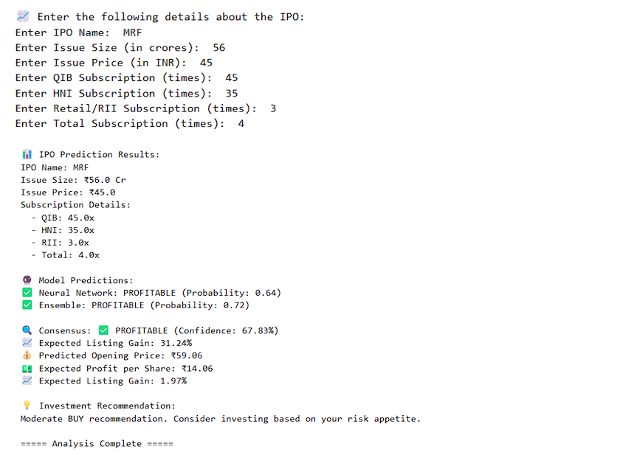

This output displays IPO prediction results for MRF using machine learning models. The Neural Network (64% confidence) and Ensemble (72% confidence) both predict the IPO will be PROFITABLE, with an expected 31.24% listing gain and ₹59.06 opening price. The system recommends a Moderate BUY, suggesting investment based on risk tolerance.

